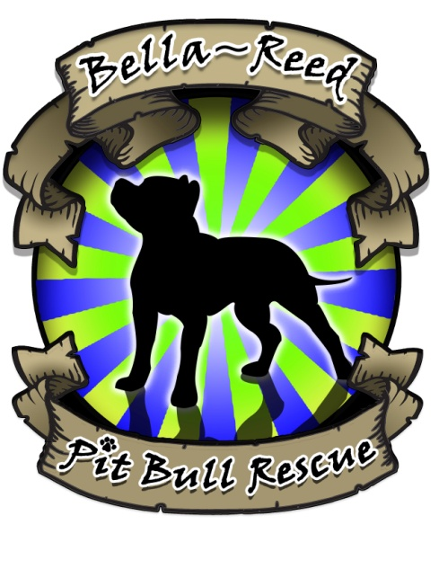
BELLA-REED PIT BULL RESCUE
PO Box 21
Southampton, PA 18966
Email: bellareedpitbullrescue@aol.com
Websites: www.bellareedpbr.com & www.facebook.com/BRPBR

VOLUNTEER APPLICATION

NOTICE: In order to apply for a position as a volunteer for Bella-Reed Pit Bull Rescue ["BRPBR"], you must:

- Complete and return this Volunteer Application, and
- Read, sign, and return the Volunteer Agreement (attached hereto).

Both the completed Volunteer Application and the signed Volunteer Agreement must be returned by email or regular mail to the address listed above, or must instead be hand-delivered to a BRPBR Board Director, before your application for a position as a BRPBR volunteer can be considered.

Volunteer Profile
Name: | Are you 23 or older? Yes No  Birthdate:
Street Address: | E-mail address:
City, State, Zip: | Home telephone:
Daytime telephone: | Work phone number:
How did you hear of the BRPBR Volunteer Program?
Have you trained your own personal dog in obedience? If so please provide the following:
Type of training? Which training company did you train with?

Reasons for wanting to volunteer with BRPBR?

If wanting to volunteer in a hands-on capacity with the dogs, are you comfortable working with pit bull type breeds?

Are you able to physically handle strong dogs on walks, etc?

Skills and Experience:

Have you had any formal education/training in pet care or animal welfare or volunteered with an animal welfare organization?
Where: When: Type of education/training:

Have you done any other volunteer work?
Where: When: Type of work performed:

Areas of Interest:
Please check all that apply.
Canine care Foster care Marketing Fundraising
Obedience Training Other (Please specify)

Do you know any BRPBR volunteers?
Name: ________________ Relationship:__________________
Name: ________________ Relationship:__________________
Name: ________________ Relationship: _________________

Have you ever been a volunteer at BRPBR before? Yes No If yes, when? ______________________
If yes, what was your reason for leaving:_____________________________________________________
Have you adopted an animal from BRPBR? Yes No If yes, who did you adopt and when? ____________________________________________
Are you a member of any other animal welfare organization? Yes No If yes, how do you participate?

Availability:

Please list best days and times for you to volunteer:

Miscellaneous:

Do you have a valid driver’s license? Yes No
Do you have any allergies or conditions that might affect your volunteer work? Yes No
If so, please describe. ________________________________________________________________________
________________________________________________________________________
Please list two personal or business references:
Name: Relationship:
Daytime telephone: Evening telephone:
Name: Relationship:
Daytime Telephone: Evening Telephone:

Please list a contact in case of an emergency:
Name: Relationship:
Daytime telephone: Evening telephone:

Vet Care:
Do you have any current pets? Yes No
If so, please state name, age, gender and whether or not they’re neutered & up to date on rabies and distemper vaccines:
________________________________________________________________________
________________________________________________________________________
Please list your veterinary reference:
Veterinary Name:
Telephone:

Response to Your Application:
Please understand that completion of this application does not assure that you will be accepted as a BRPBR Volunteer. Accuracy and completeness of this form are important in determining the acceptability for a volunteer position with BRPBR. You may also be asked to submit additional references and participate in additional interviews, all of which are considered part of the qualification process. All pre-placement inquiries are made for the purpose of establishing your qualifications for volunteering with BRPBR.

Volunteer Agreement:
If accepted as a BRPBR volunteer, you will be required to abide by the terms of our Volunteer Agreement. The Volunteer Agreement you will sign details what BRPBR will expect of you and what you can expect from BRPBR, including confidentiality.
Please note that your execution of the Volunteer Agreement is part of your application process, and must be completed before your application to volunteer for BRPBR can be considered and processed.
Please read and sign the Volunteer Agreement, and submit it as part of your application.

Today’s Date: ________________________________________________________________________
Applicant Name (Please Print):
________________________________________________________________________
Applicant Signature: ________________________________________________________________________
Date Signed:
________________________________________________________________________

BRPBR Representative Name (Please Print): ________________________________________________________________________
BRPBR Signature:
________________________________________________________________________
Date Signed:
________________________________________________________________________
Approved____ Denied_____

